1) Flowchart to log in to Facebook account with valid email address and password.

**Algorithm:**

**Step1:** Accept Facebook.com.

**Step2:** Open Facebook home page

**Step3**: Accept Email Id and Password

**Step4**: If both are correct (condition check)

**Step5**: Display Valid

**Step6**: Otherwise Invalid

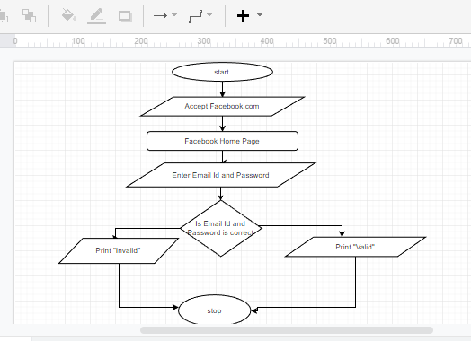

2) Flowchart to purchase a mobile phone from Amazon.

**Algorithm:**

**Step1:** Open Amazon Application.

**Step2:** If you have an account sign in other wise register and then sign in.

**Step3:** Search Mobile phone**.**

**Step4:** Select mobile.

**Step5:** Click to Add to cart.

**Step6**: Add address.

**Step7:** Proceed payment

**Step8:** Order placed and Purchased.

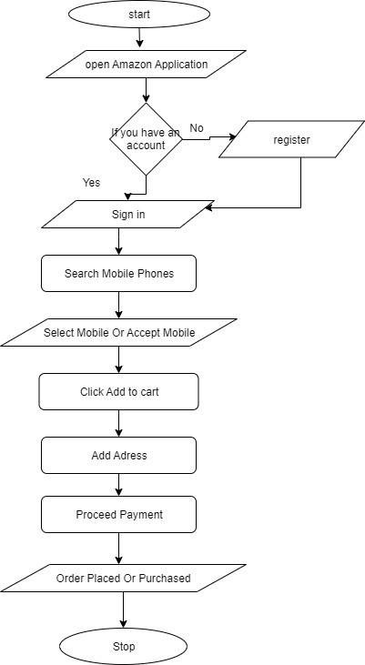

3) Flowchart to Predict Winning Chances of team on the basis Live Cricket Score.

**Algorithm:**

**Step1:** Accept two Teams.

**Step2**: If Team A Score is Greater than Team B

**Step3**: Display Team A.

**Step4**: Otherwise Team B Score will Display

